

**Nota:**

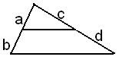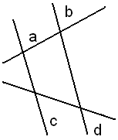

a + b = a

n m

a = b

c d

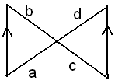

a =b

 a = c d c

b d

**Ejercicios:**

En cada figura calcule X:

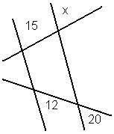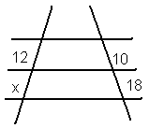

2.

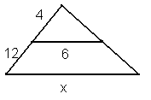

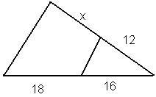 3. 4.

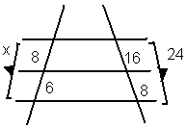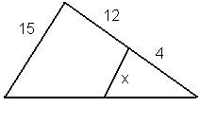 5. 6.

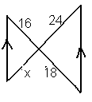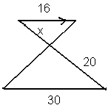7. 8.

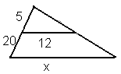9. 10.

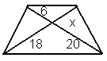

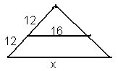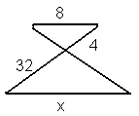11. 12.

**Repuestas:**

1. x = 21.6
2. x = 25
3. x = 24
4. x = 13.5
5. x =14/4
6. x = 18
7. x = 24
8. x = 21.3
9. x = 5.4
10. x = 60
11. x = 64
12. x = 32